Ocean Liu

Intro to computing

May 6, 2015

**Abstract**

This paper analyses the data provided by the NASA GISS database and compares them to the claims that NASA and other government organizations make about climate change. In the latest climate change report by the US Global Change Research Program, a group of government agencies including NASA, claims are made pertaining to the impact of climate change as well as the role humans play in this phenomenom. What will be tested in this paper is the claim about the change in the Earth’s climate; more specifically, the claims about the increasing rate of change in the temperature on Earth in the past sixty years.

**Background**

Climate change and is one of the most urgent issues that NASA concerns itself with. NASA believes that human activity has created unnatural warming over the past few decades. They have stated that natural factors such as solar forcing and volcanoes should have actually cooled the Earth, and that other natural variations due to events such as El Nino and La Nina are too small to explain the amount of warming over the past 50 years. Apart from rising temperature, scientists are afraid of the effect that this will have on the ecosystem. Potential disasters that may occur due to climate change are rising sea levels, melting glacier caps, as well more instances of extreme weater. While there have always been natural variation in climate, scientists believe that there is too extreme of an increase since 1950.

**Materials and methods**

Matlab and Python were used to organze and analyze the data. The data was retrieved from NASA’s GISS database and include the temperature data from 1880-2014 from meteoroligist stations and are meaured in deviations from the base period temperature. The python script will produce calculate the mean deviations each year as well as the estimated average temperature each year and organize the data and calculations in a form that is easily importable to Matlab. The Matlab script will read the data in the file new_out.txt and produce scatter plots that compare the year and the deviation and temperature. Then it will produce a scatterplot that limits the time interval to between 1880-1950, which scientists believe was the point before human activity started to have large impacts on climate. Using the basic fitting tool, I will fit both of the graphs to a quadratic, which would indicate a spike in the temperature increase toward more recent and calculate the R-squared values and see how well each fit is.

**Analysis**

The graph below show the average deviations from the base period in the time 1880 to 1990. The average deviations are measured in hundrth The second graph includes the actual estimated temperature values instead of deviations, to give a sense what the temperature has actually been like. Celcius. Based on the graphs we can see there is obvious increase in temperater. After fitting the with the quadratic fit and linear fit and calculating the R-squared value for each, we see that the quadratic fit suits the data better that the linear fit. However it is possible that the data has always fitted this trend, that it has been increasing quadratcally before 1950 which NASA believes was when temperatures began to spike. Thus we ran the same analysis on an isolated set of data, one including only the years from 1880 to 1950, the years that where human impact was less profound, shown in the third graph. In this case however, the the R-squared values for the linear and quadratic fits are practiacally identical. Showing that the trend in the data at that time didn’t show a significant increase in the rate of warming compared to a constant rate.

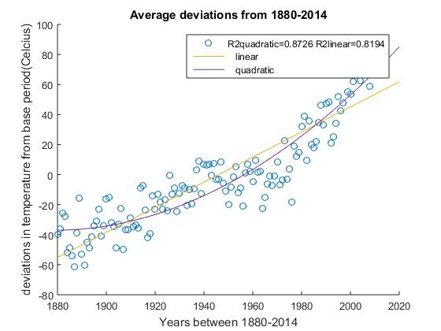

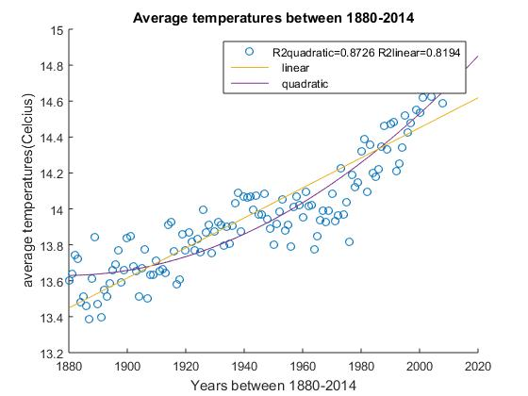

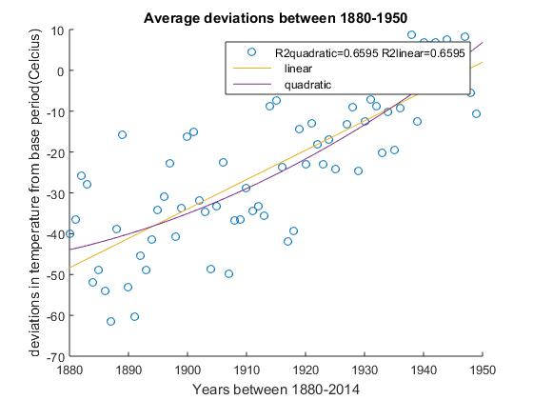

**Conclusion**

The analysis compares the trends between the entire data set, and that isolated to the time period before the believed spikes in human related increases. What was shown was that over the entire data set, the quadratic fit was a much better model for the data set than the linear fit, giving reason to believe that the rate of change definitly increased at a higher rate in more recent years. In contrast, in the years before 1950, the data cold be fitted with a linear and quadratic fit equally well, showing that the rate of increase was not profoundly changing. This seems to agree with the reasearchers claim that the climate has increased much more in past six decades. While this analysis does not link the change in the rate of change, it show that the temperature increases seem to be more extreme as of recent years. The next step would be to establish a more solid link between this current phenomeno and human activity.

**References**

Melillo, Jerry M., Terese (T.C.) Richmond, and Gary W. Yohe, Eds., 2014: Climate Change

Impacts in the United States: The Third National Climate Assessment. U.S. Global Change Research Program, 841 pp. doi:10.7930/J0Z31WJ2